Room 1 Second and Third Class
Hello boys,
I hope that you and your families are well.
I made a list of items for you to do over the next week.
History- Before we left school, we were studying The Vikings. I have attached a summary.
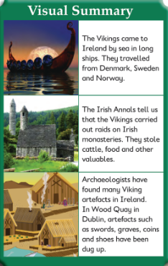
I would like you to do one of the following
- Draw a long ship used by the Vikings to travel across the ocean
- Build a Round Tower – we looked at a round tower in Ardmore Co. Waterford
- Research and write five point about The Vikings
Maths Continue on with 2 pages of mental maths – Mon – Friday Review.
Second class: Tables -10 Third Class ÷ 10
English: Do the next three stories from Read at Home with the questions.
Art: Design and decorate an Easter card
2nd Class Religion – Complete the pages about the Easter Story
Learn your prayer before communion at the back of the Grow in Love book.
Learn the chorus to ‘Happy in the Presence of the Lord’ – here are the words;
Happy in the presence of the Lord
We come and sing our prayer to Lord Jesus,
Happy in the presence of the Lord,
We come and sing our praise to the Lord of all.
You can listen to the song on YouTube… https://www.youtube.com/watch?v=xr68dt2iptM

Email: christine@themonasteryschool.ie

